Summer 2023 Indonesian News

Colin & Ellen McKee 205-590-1376; cohamckee@att.net

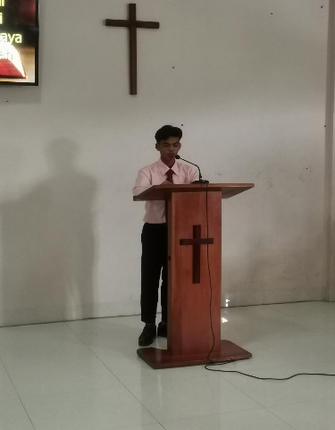

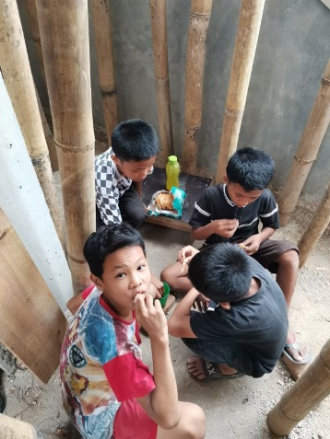The children’s facility that is being added to the **Medan** church building is making great progress. They are now working on the top floor and hopefully will soon be able to put on the roof. The children have often helped with cement mixing and forming a human chain to get the mixture to the workers for pouring. Two of the young men who are residents in the home were baptized last year are now taking part in conducting worship service.

Young man from children’s home helping in worship

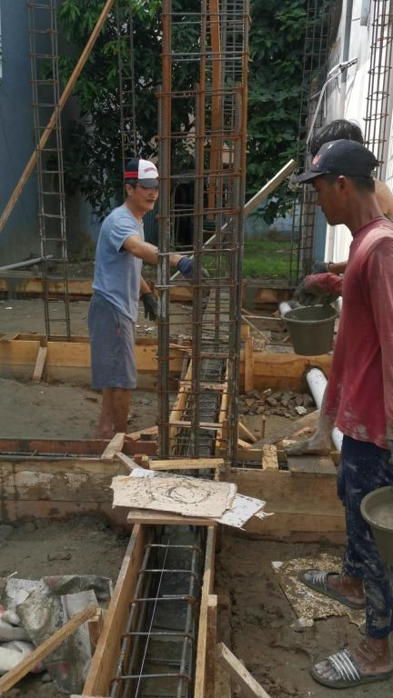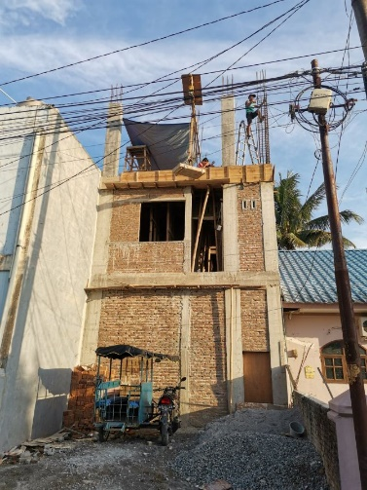 Construction encountered a disruption a month ago when a thug attacked the Medan preacher, brother Ndruru, with a machete. That happened after Sunday worship service when all the congregation had gone home. Thankfully the construction workers were still on hand and intervened to help brother Ndruru and the man was overpowered before doing serious or fatal injury, other wise he could have killed our brother. Of course he was after money since he deduced that a building project would involve funding.

Kids helping with construction

The matter was reported to the police but since the thug is a friend of several policeman, likely dividing with them his spoils from time to time, nothing has been done to him. They made videos of the encounter, but the man has not been apprehended. Please pray that the building project and the work of the church will not be further hampered by threats from this criminal, or any others who might want to take advantage of those who are not armed to ward off such attacks.

Going on up!

Bro Tuloasa helping with construction

Up.up to the top

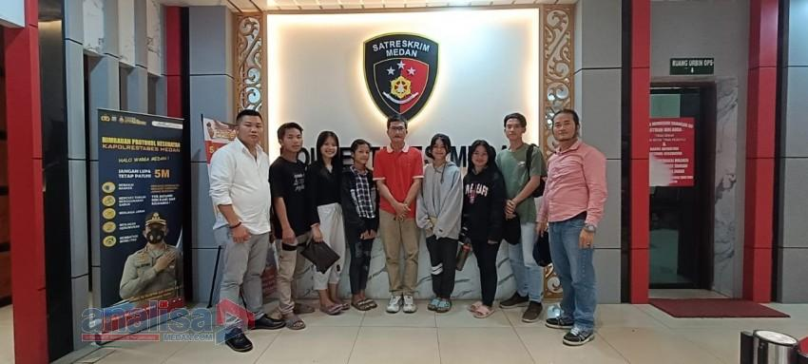

Bro Tuloasa, some children from the home, and legal advocates making a report about the attack to the police

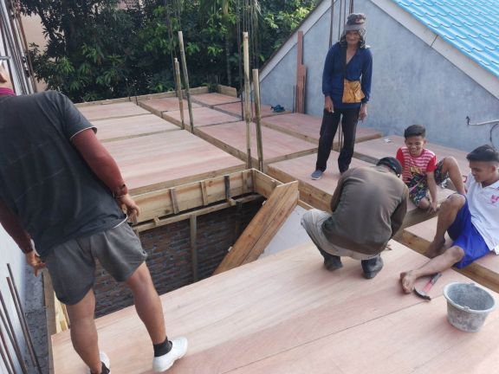

Real manual labor. They have an electric cement mixer but everything else is strictly hands on labor.

**News From Java**

 We have just finished printing the second volume of The Anvil Rings (Paron Berdentang) in Indonesian. Brother Alip is now distributing it to the churches. We will soon begin translating the third volume. All these books in Indonesian are extremely valuable for the equipping the brethren in Indonesia to defend the faith to defend the faith against unbelievers who attack the veracity of the Bible. Brother Alip is preparing materials he has translated for Truth for Today to be put on their website and thus making them available to all Indonesian churches and Indonesian speakers. He also continues to make regular trips to Limbangan in East Java to teach and encourage the brethren there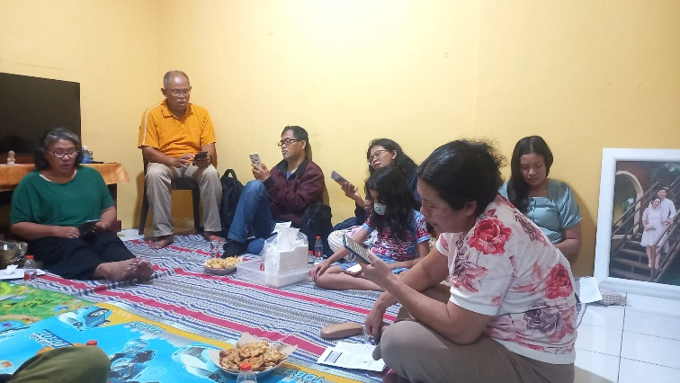.

Bro Alip teaching class in Limbangan. Notice everybody using cell phones for Bible text.

My Indonesian radio program is still receiving very good attention. From **January through May** there were **4604** visits to the site and **460 lessons downloaded**. That is an average of **92 downloads per month** and over **920 visits per month**. We continue to have visits from all over the world, with the largest number still coming from the U.S., but many from China, Great Britain, India, Indonesia, Hong Kong, Thailand, and Malaysia. **The weekly online class** is going great with Indonesian brethren from cities and islands all over the country taking part and teaching on a rotating basis. More than **20** usually take part.

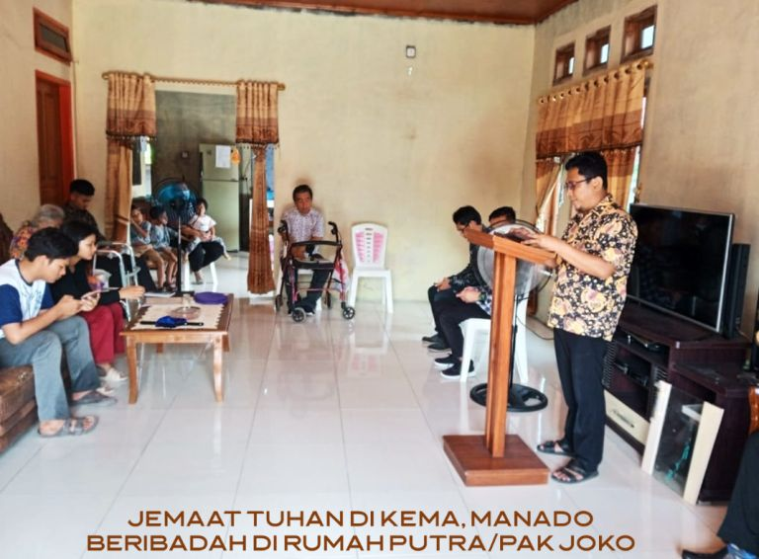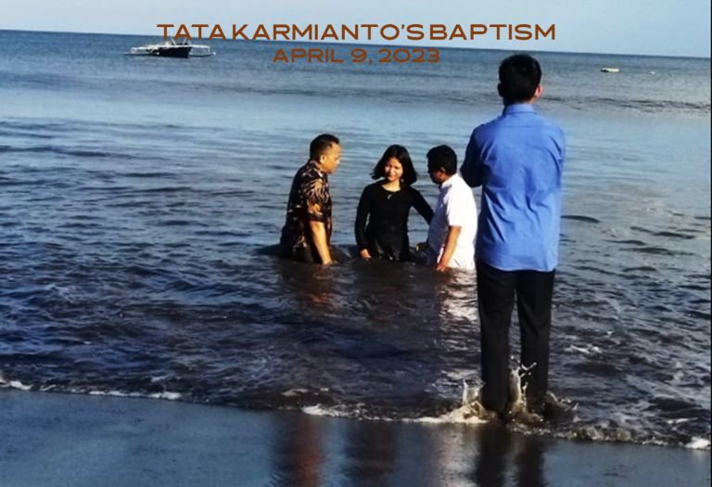 **Great news about new converts in Manado on Sulawesi Island.** In October of 2022, Putra Akwila contacted the **Truth for Today** office in Searcy asking for additional study materials as he had studied the book The Life of Christ by David Roper that he had obtained from a local gospel preacher, brother Najoan, in Suwaan, Manado. They forwarded the contact to brother Alip whom I work with in doing their translation work in Indonesia. He then forwarded the contact to Alex Daniel, the director of Manado Bible College. After further study, **Putra** was baptized and then he shared the gospel with family and friends. His **father** was soon baptized, then his **father’s friend,** then his **sister Tata,** and finally Putra’s **friend**, **Aldo** was baptized just last month. They now make up a new congregation that worships in Putra’s house in Kema Village, Manado.

Baptism of Putra’s sister Tata, Manado

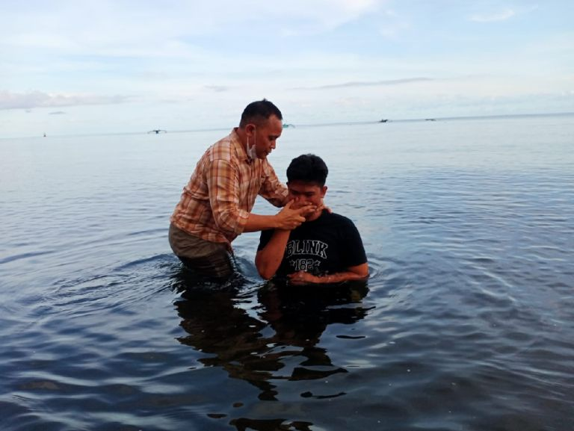 Please pray for the new converts and all the work in Indonesia.

Putra Akwila’s baptism, Manado

Worship in Putra’s home, Kema Village, Manado

InChrist,

Colin & Ellen