Colin & Ellen McKee

205-590-1376 cohamckee@att.net

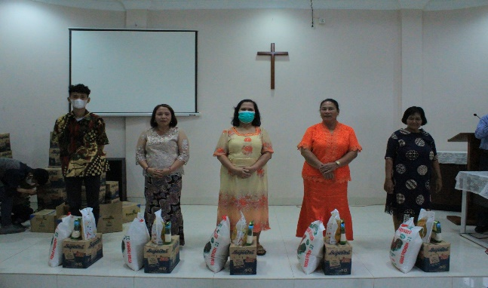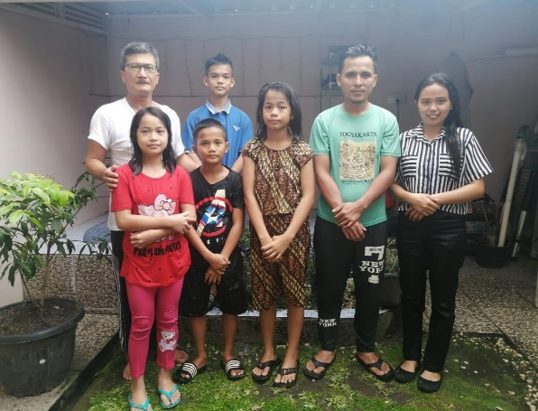

Some of the families receiving food assistance

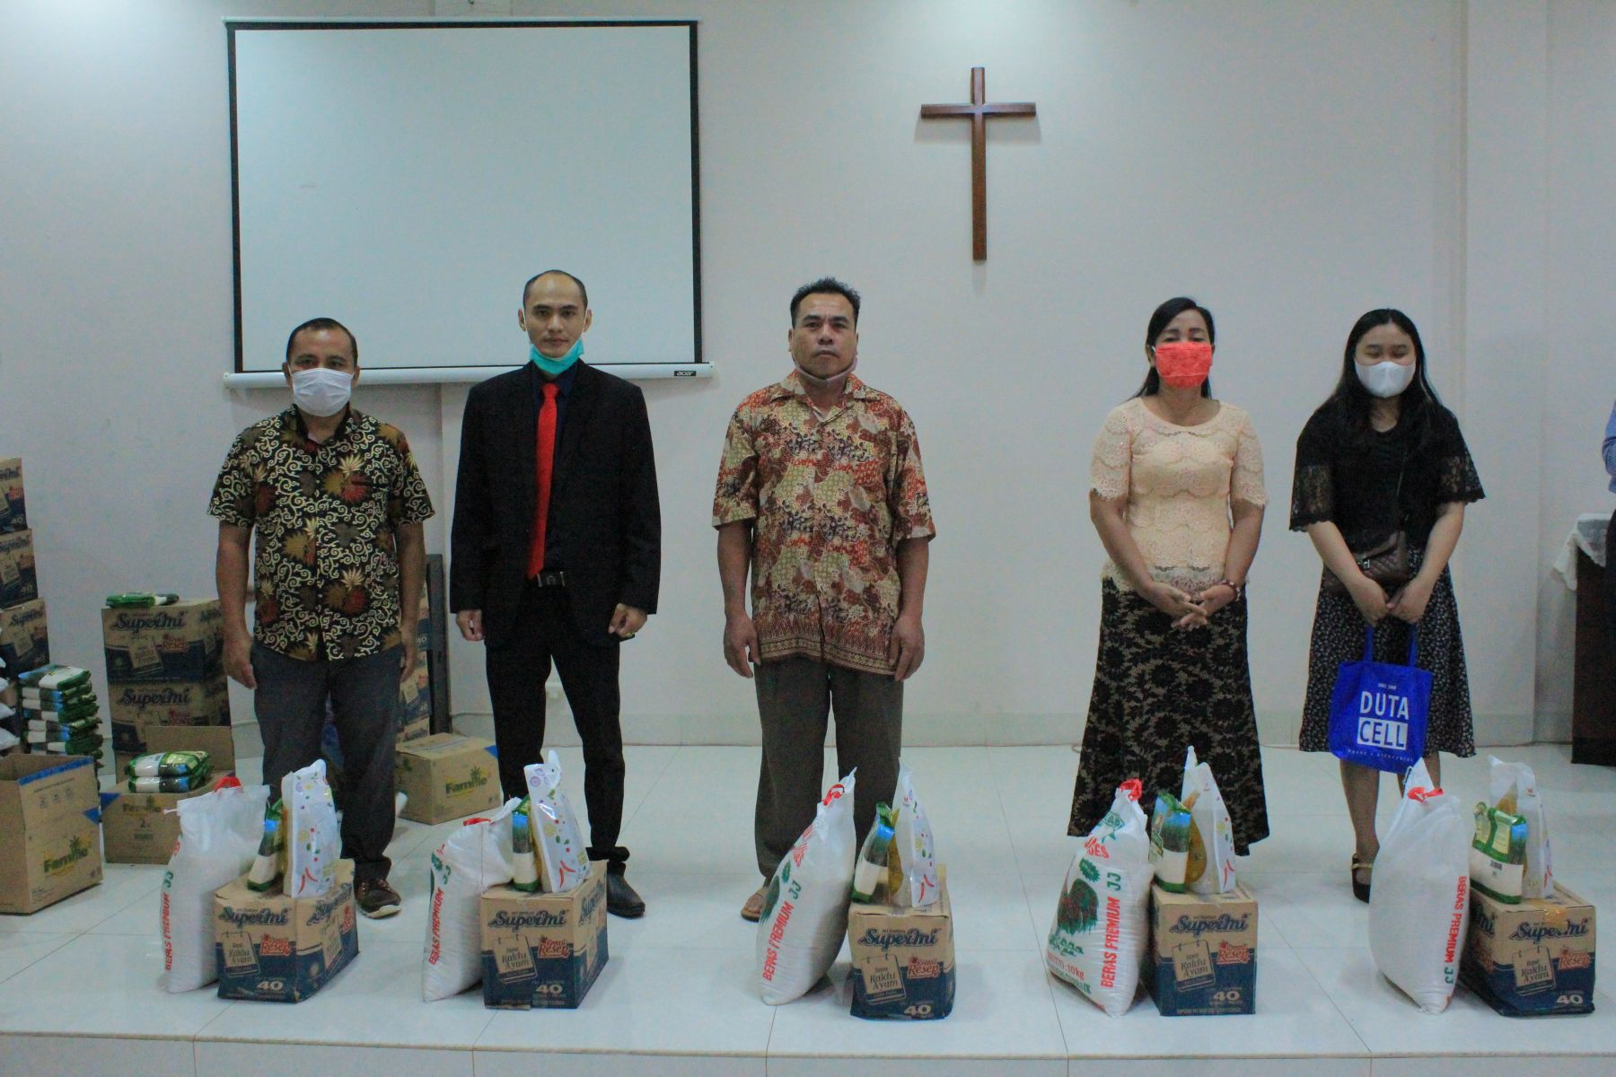

Orphans in Medan who were baptized

The Covid virus has truly become a world-wide disaster, and now the advent of a new variant threatens to further impact a struggling global population. The pandemic continues to negatively impact a number of our church members, especially in the Selayang congregation in Medan. Many of the members there are low-income families and the men often work as Grab drivers (similar to food deliveries in the U.S.). They use motorcycles for their work to fill orders and deliver to their customers. Since social contact has been curtailed in many ways by the government, even to prohibiting some churches to meet in certain areas, it has made it difficult for these brethren to make a living. In areas where social mingling is not as restrictive, many are reluctant to carry on as usual because of the fear of the virus. As far as I know at this time none of our brethren are suffering from the virus, nor is anyone in isolation because of contact with someone who has it.

The Selayang congregation is still meeting for regular assemblies and several have recently been baptized, including the orphans under their care. We are thankful that those who oversee the children have included in that care the concern for their spiritual welfare. Brother Ndruru has also trained three younger men to help in conducting worship and preaching and they rotate in leading the services. We are still supplying basic food necessities for a number of the families in the Selayang congregation as the economic impact of Covid continues to hit them hard. A total of **20 families** received help in the last distribution

Although several earthquakes and volcanic eruptions have recently taken place, thankfully none of our brethren have been directly affected by those upheavals. Indonesia sits on the infamous Ring of Fire which is the most active area of the world for those occurrences and the people of that nation are always subject to the vicissitudes of nature. The last two events happened on Java, and off the coast of Java, but did not cause massive destruction as so many eruptions and tsunamis have caused in the past.

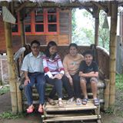

Hello from

Indonesia

Indonesian Update Winter 21&22

My shortwave **radio program** is receiving a lot of attention as the visits and downloads of lessons are increasing. From September to December there were **2370 visits** to the program website and **312 lessons** downloaded. Visitors from all over the world include those from the U.S.A., Great Britain, Germany, India, China, Netherlands, Australia, Indonesia and Malaysia. We had more visits from Indonesia this period than any previous period. Also noteworthy is the fact that although Indonesians are scattered all over the world, Netherlands, who once colonized Indonesia has a large population originating from Indonesia, Australia who is their next-door neighbor has a sizeable population, and Malaysia shares a common language with them. It is encouraging that many people are hearing the message of the gospel in their mother tongue from this medium. I continue to assist brother Alip in the translation of materials for **Truth for Today**.

I am also enjoying taking part in an **online Bible class** with the brethren in Indonesia. It takes place at 6:30 a.m. here which is 7:30 p.m. there. I take part with brethren from across Indonesia in teaching the class on a rotating basis which is followed by a discussion session.

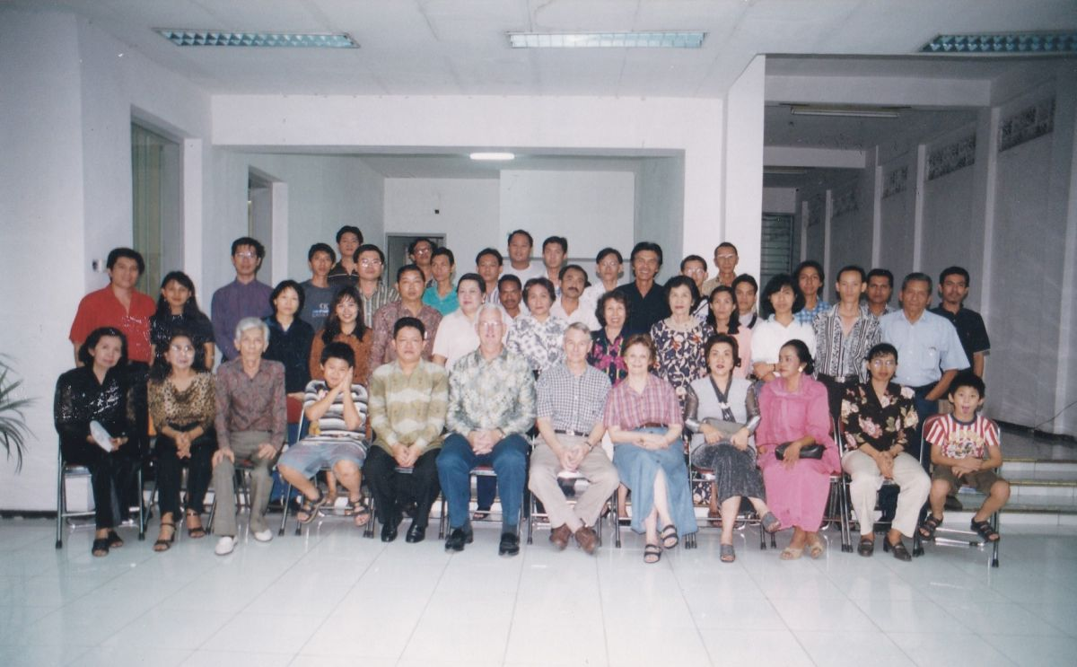

Duane Morgan next to Ellen and me in WBS seminar, Surabaya, Indonesia, 1999

Fellow missionary Duane Morgan with whom we have worked in World Bible School seminars across Indonesia over many years is now suffering from prostate cancer which has metastasized. He now lives in Malaysia with his wife Phyllis but he is still teaching online in Malaysia and taking part in the Indonesian online Bible class. Please pray for him that God will provide what he needs at this critical time.

As I reported last time, recent printing efforts include the four basic courses of World Bible School books in Medan and in Jakarta the book on Mengapa Saya Adalah Anggota Gereja Kristus “Why I Am A Member of the Church of Christ”, written by Bill Cantrell of Huntsville, Al., and the reprinting of my book on Marilah Kita Baca Dalam Alkitab “Let Us Read It In The Bible”. These books will be tools for our Indonesian brethren to be grounded in the faith and equip them to defend it against falsehood. All of the members in Selayang, Medan, are being encouraged to take the World Bible School courses. It will be very effective in strengthening their faith.

World Bible School books

Book “Why I Am A Member of The Church of Christ

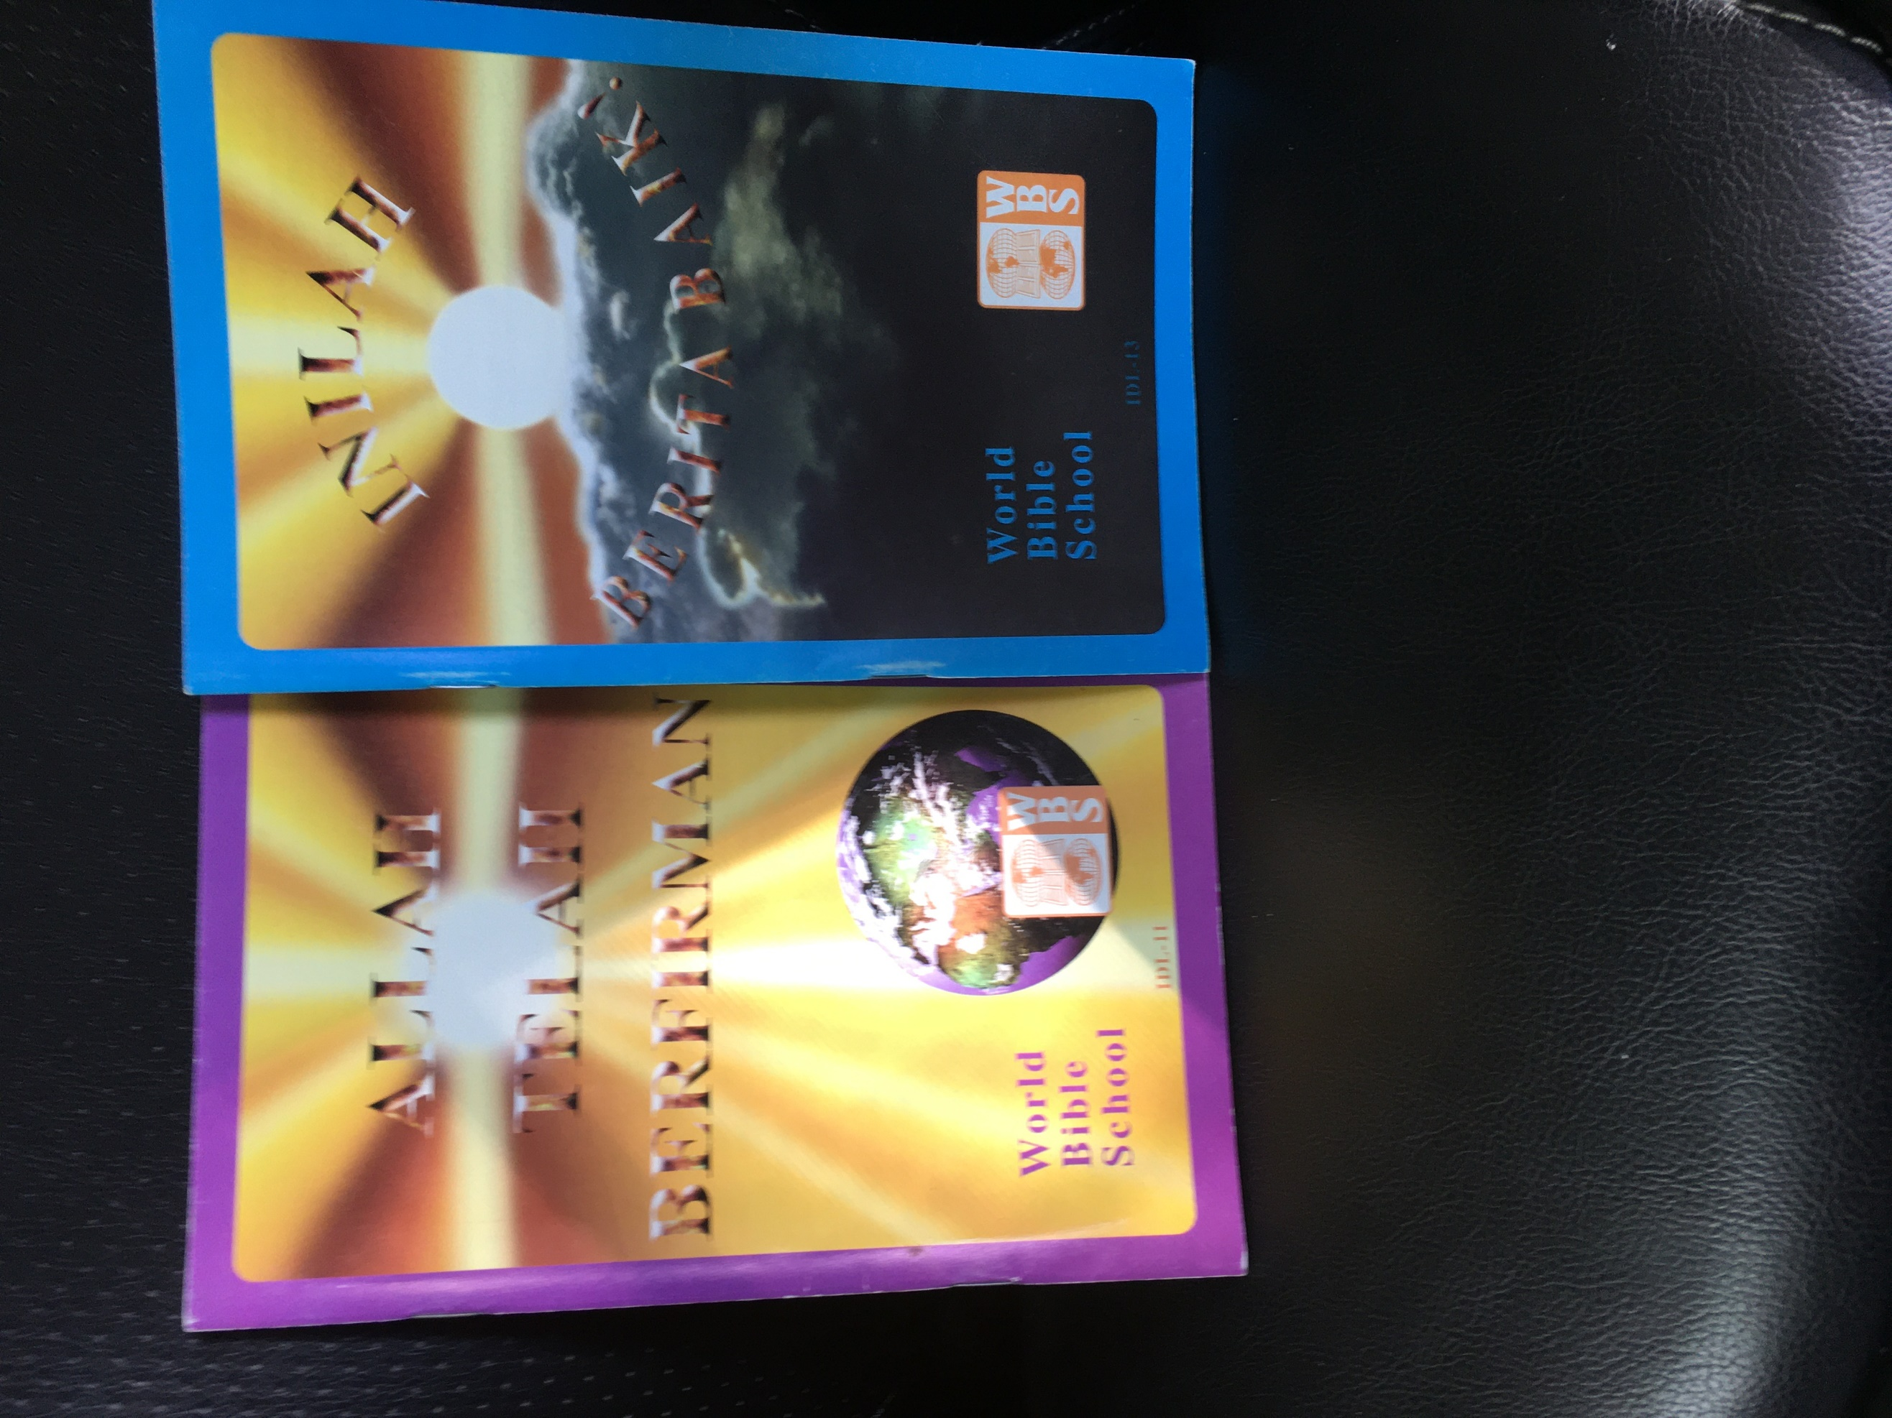

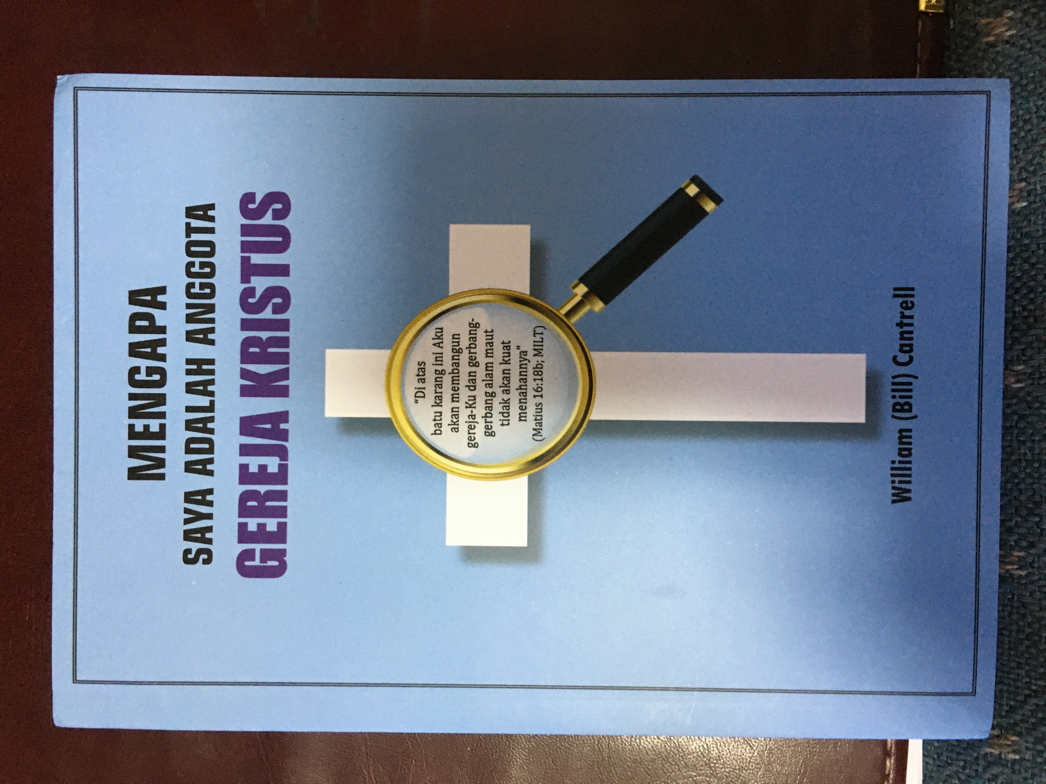

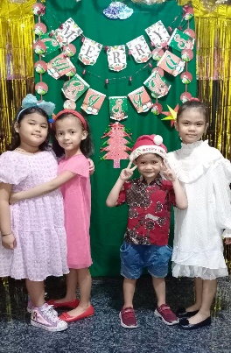Daniel Setiabudi reports that his family can now go out to shop for food and necessary supplies since they have received the Covid vaccination. They have to show proof of vaccination when they enter public places. He conducts a weekly radio program that has to be done by streaming since the station is still not allowing live broadcasts because of the pandemic. The children at Connor House under his oversight are doing well and enjoying a school break. We were there when those kids were newborns and it is exciting to see their growth and development

Connor House Kids

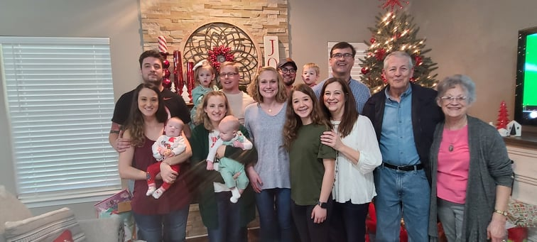

Ellen and I got our Covid boosters and after a couple of “yucky” days we were fine. We were able to spend some time with our daughter Beth and her family over the holidays. Our son Marcus came by for a short visit as he was managing a display for World Bible School at a Youth Event in Huntsville, Al., then had to return to Highland Village, Tx.

Many thanks to all who give to make the work possible in Indonesia. Please continue to pray for our brethren there. May God bless each of you in 2022 with rich blessings!

At Sammy & Beth’s with 5 great grand kids!

Ellen and I have received the Moderna booster and other than for a day and a half feeling like a truck had run over us we are doing fine.