Indonesian Spring news report

Mission news from the McKees

Most of the world has been severely impacted by the Covid 19 pandemic. Indonesia has been hard hit as well and a few of our brethren have contracted the virus, but no deaths have been reported. One young man, a member in Jakarta, who was a pilot for Air Asia, died when his plane went down in the Java Sea and all on board were killed. He left behind a wife and two young children.

Ellen and I have recovered from Covid but still have lingering after effects. We are due to get the vaccination in a couple of weeks. Our brethren in Indonesia are now getting the vaccinations with the vaccine coming from China.

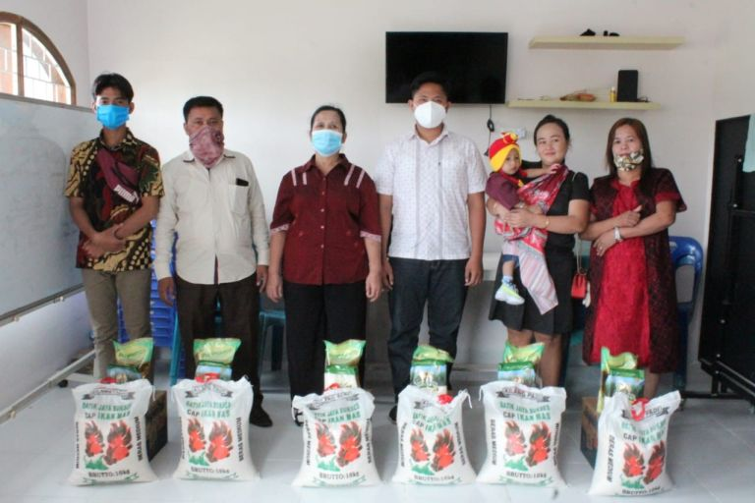

Some of church members receiving supplies

The pandemic is still wreaking havoc with the ability of many of our brethren in Medan to make a living and we have been supplying funds to help them on a regular basis. We provide some of the basic food necessities such as rice, cooking oil, sugar, and instant noodles. Some 20 families have been receiving help and they are extremely thankful for the support that has been given during this pandemic.

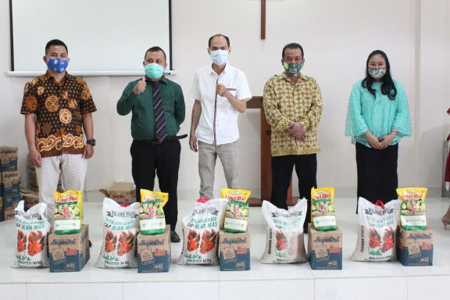

More food distribution.

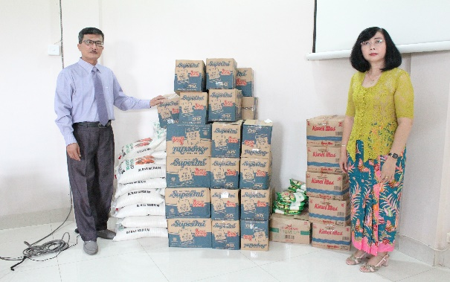

Tuolasa & wife Noefi preparing food supplies for distribution.

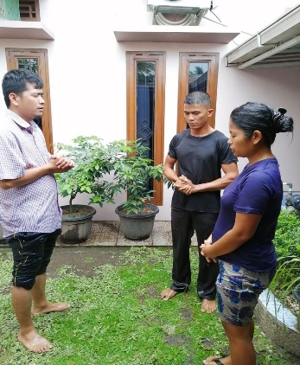A young husband and wife couple (Sudarman Telaumbanu and Karina Hati Ndruru) was recently baptized in Medan at the Selayang congregation. We are so thankful that souls are still responding to the gospel in the midst of turbulent times.

Brother Tuloasa’s grandson, Arga, fell and broke his arm and had surgery to insert a pin but is doing well and recovering rapidly.

Recent baptism, Medan

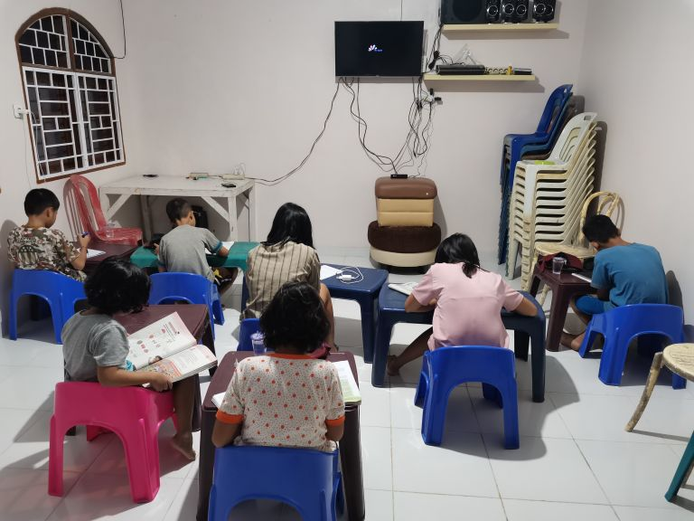

Selayang orphans doing home work.

The orphans under the care of the Selayang congregation are doing well and now have access to WIFI at the church building to assist them in school work. The orphans in Bekasi under Daniel and Naomi’s care are doing well and Daniella recently won a singing contest.

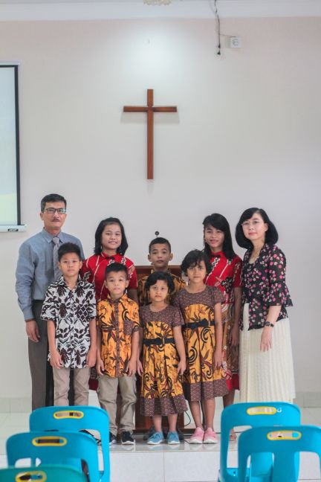

Tuloasa and Noefi with the 7 orphans cared for by the Selayang church.

My Indonesian shortwave radio program is still receiving a lot of hits and visits. From October till February there were **3173** visits to the website from various countries including the U.S., Europe, and Asia with **46 from Indonesia.** There was a total of **58 downloads** of printed lessons during that time. The lessons that are aired are available in PDF format from the **Inilah Berita Baik** website. Some of the most recent lessons have been series on Biblical Authority and The Church of the Bible.

Many thanks to all of our supporters who are continuing to help with the work in Indonesia and for helping to meet the pressing needs of brethren and orphans who other wise would be destitute

Daniella from Connor House. Winner of district singing contest for school children.

I am taking part in an online Bible class from Indonesia that is conducted on Wednesday and Sunday nights. I am scheduled to teach the class again on April 21. It is aired through Google Meet and is an interactive class with around 25 participants each time from all over Indonesia and Malaysia.

One of my brothers, Don, passed away on March 11. He had tested negative for Covid but exhibited many of the symptoms associated with the virus, and was hospitalized for a month before succumbing to all the complications. All of his family had Covid. Please remember his family in your prayers. He was an elder in the church, an author of numerous books and a regular newspaper columnist and leaves behind a legacy of Christian service and commitment.

Colin & Ellen McKee

[cohamckee@att.net](mailto:cohamckee@att.net)

205-590-1376

Our work on helping with the translation of **Truth for Today** materials continues at a steady pace. We just finished the commentary of 2 Corinthians and will be starting on James next week. We have already translated numerous study guides and commentaries. I also translated an issue of **House to House** at their request to be put on the church web site in Indonesia, and will soon be translating other issues along with bro Alip who does the regular translation of Truth for Today.

