



**McKees Fall 2020 Indonesian News**

**Greetings** to all of our friends and supporters. The pandemic continues to adversely affect every corner of the globe and has also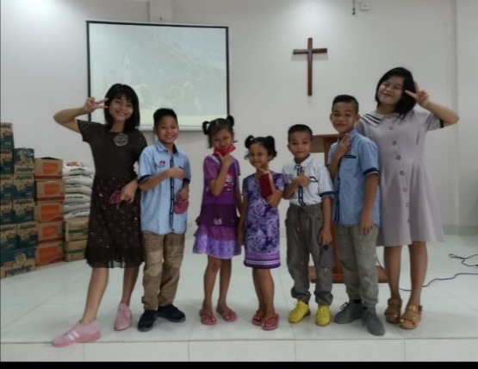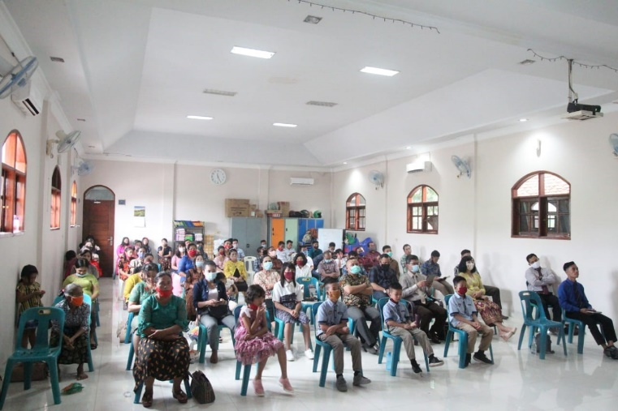effected changes for the work of the church in Indonesia. Things are going well there, but adjustments had to be made to accommodate the new normal, and many are using the internet in ways that were not so common in the past. I recently participated in a Sunday night and Wednesday night Bible class conducted by brethren from Indonesia and Malaysia that was shared across those two sister countries and plan to take part in more of those in the weeks ahead.

Recent worship, Selayang , Medan

7 orphans cared for by Selayang, Medan

7 orphans, Selayang, Medan

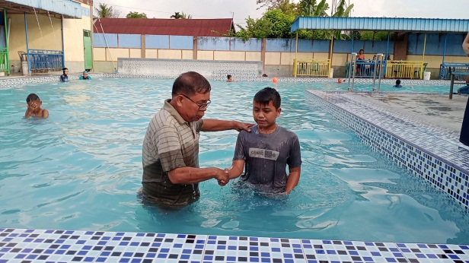**MEDAN:** The **Selayang** congregation met as families in their homes for a while, but now have returned to regular assemblies while observing the new Covid protocol that is mandated by the government. Some of the brethren in Jakarta still have not been able to return to regular assemblies as they meet in rented facilities. The Selayang youth group is active with group studies and other outside activities. Two more orphans are now under the care of the Selayang church, sisters aged 8 and 10. Their father is in prison for drug dealing and their mother has become a “lady of the night”. Their grandmother was no longer able to take care of them. The congregation has recently renovated the classroom area of the church building as it had fallen into disrepair. We have sent funds to help the brethren there as many of the men work as delivery men for call in orders from fast food places and the pandemic has severely curtailed that enterprise, so their income has dropped drastically. More than 20 families have been helped.

Recent worship, Selayang, Medan

Classroom reno Selayang, Medan

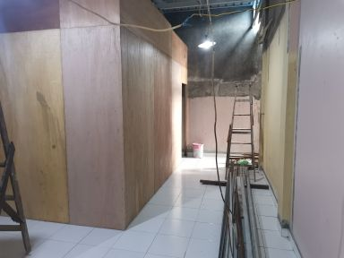Two young people were baptized recently at the **Pokok Mangga, Medan** congregation. The church there is small and the older members are afraid to assemble because of the virus, but brother Andrew and his family continue to help with conducting services there and elsewhere in N. Sumatra.

**South Nias :** I mentioned brother Andrew Banjarnahor who lives in Medan and is sponsored by the Lake Jackson church in Texas. He makes frequent trips to South Nias to train and evangelize in that area and helps with the training and transportation of a number of local preachers in South Nias Five were recently baptized in two different areas of South Nias and six were baptized in Jambi which is located just north of the Province of South Sumatra and to the east of the Province of Bengkulu. That is quite a distance from Medan, and brother Wau from South Nias who has family there, was the one who established that congregation about two years ago and it is growing steadily.

Recent baptism at Pokok Mangga, Medan

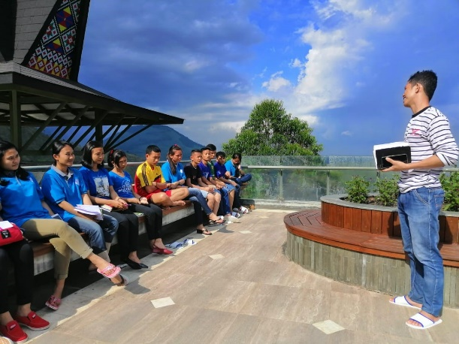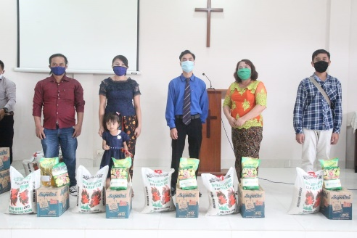**Other :** My weekly Indonesian radio program continues to receive many visitors to our website. In August, September and half of October there were 1476 visits and 59 lessons downloaded. There were visitors from all across the globe although it is aimed primarily at S.E. Asia with the intention of targeting Indonesia.

Youth devo, Selayang, Medan

Some recipients of food distribution. Selayang

Youth devo Selayang, Medan

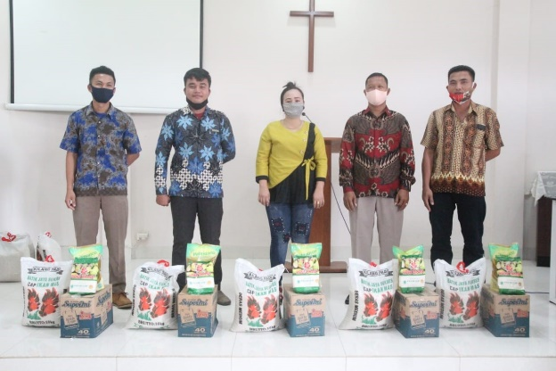 I continue to help with editing Truth for Today translation as well as preparation of other materials for the churches of Indonesia and recently helped with proofing and editing World Bible School materials which are placed on a blog spot for the churches in Indonesia that Steve Cate and Daniel Setiabudi have set up.

Some recipients of food distribution, Selayang

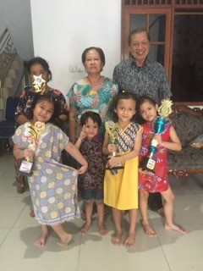

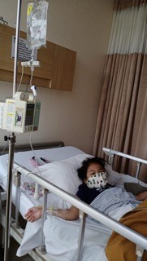 Betty Choate has supplied some funds donated for benevolence to help with the care of orphans in the **Connor House in Bekasi**. Those funds will be distributed periodically to Daniel Setiabudi as he and Naomi are the full time care givers for that facility. One of the children, Daniella, was recently hospitalized but is back at home and doing much better.

Please keep all of these works and the nation of Indonesia, as well as our own country, in your prayers that the vaccine for the pandemic with be forth coming and citizens of the globe can have what they need to deal with this current danger.

Daniel & family with children in the Connor House

Daniella in hospital, Bekasi

In the Master’s service, Colin and Ellen [cohamckee@att.net](mailto:cohamckee@att.net), 205- 590- 1376

Daniel’s family & Connor House kids, Bekasi

Classroom reno Selayang, Medan

Youth devo, Selayang, Medan

Pics of some of recipients of food aid, Selayang

Recent baptism, Pokok Mangga, Medan

Daniella in hospital in Bekasi

Seven orphans, Selayang, Medan

Recent worship, Selayang, Medan