**McKees Indonesian News May 2020**

Indonesia has been a land of disasters since our last report. They have been besieged by storms and flooding twice this year with the worst destruction in many years. The Jakarta metro area was inundated to about 4 feet inside many sub divisions and Daniel Setiabudi’s neighborhood in Bekasi suffered the same calamity. They had to discard mattresses and other things that were too damaged to salvage. Their appliances on the second floor were thankfully spared. Brother Alip’s house in Jakarta flooded up to about three feet and they thought their appliances were lost, but somehow after they dried out he got them working again. He did lose some books and other written material. Many residents throughout Jakarta Metro lost most of their possessions and suffered extensive damage to their homes.

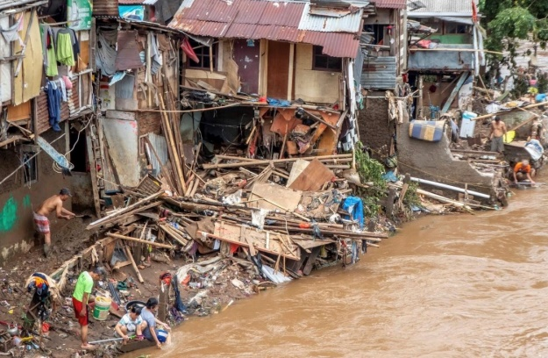 Now the Covid 19 pandemic has brought everything to a standstill just as here and elsewhere. Many are struggling with work and services curtailed. Daniel and his family have been distributing meals/food to those in his immediate area. The country is practicing social distancing and most businesses are closed. Indonesia does not have the capability to deal with such a crisis to the degree that more developed countries handle it. Testing and treatment are the big challenges, especially outside of the large cities where medical facilities leave much to be desired. As far as I know none of our brethren has come down with the virus at this time.

Flooding in Jakarta Metro

The Selayang church in Medan has taken the care of five orphans that came from a church in the Sibolga area of North Sumatra. They are being supported from our Indonesian Fund and are being housed in a part of the church building where a custodial family lives. A husband and wife were baptized at Selayang recently.

Our weekly radio program continues to receive a lot of attention from various places around the globe. PDF copies of the lessons are regularly downloaded. I am working on translating books and authoring articles/tracts for the churches and will get some finished and printed soon.

We pray that everyone will be well and that God will protect each of you in these uncertain times. Let us consider His message to His people in the O.T. *“But now thus says the Lord, who created you, O, Jacob, and He who formed you, O Israel : ‘ Fear not, for I have redeemed you; I have called you by your name; You are mine. When you pass through the waters, I will be with you; and through the rivers, they shall not overflow you. When you walk through the fire, you shall not be burned, nor shall the flame scorch you. For I am the Lord your God, the Holy One of Israel..’ (Is.43:1-3).* In Him, Colin & Ellen McKee : 205-590-1376, cohamckee@att.net

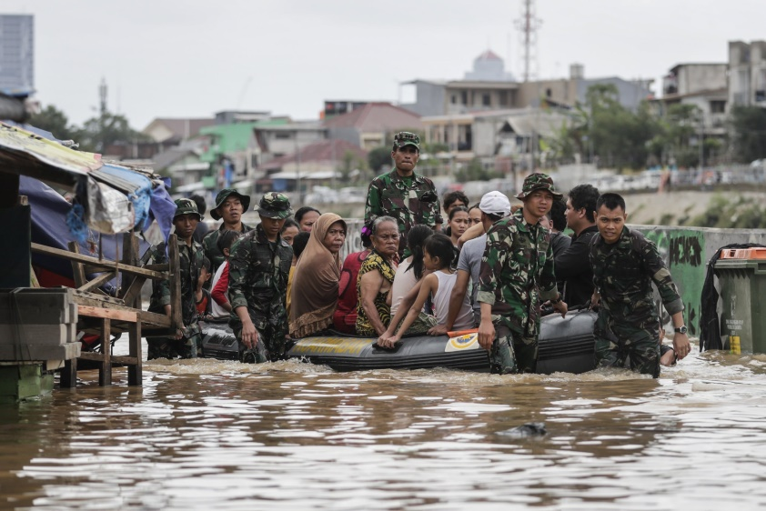



**Visits to site Feb.-April** : **979**

**Downloaded lessons** : **Feb.-April** **45**

**Visits from many locales including:**

**U.S., Great Britain, Ukraine, Indonesia, Malaysia, Netherlands, and Turkey**

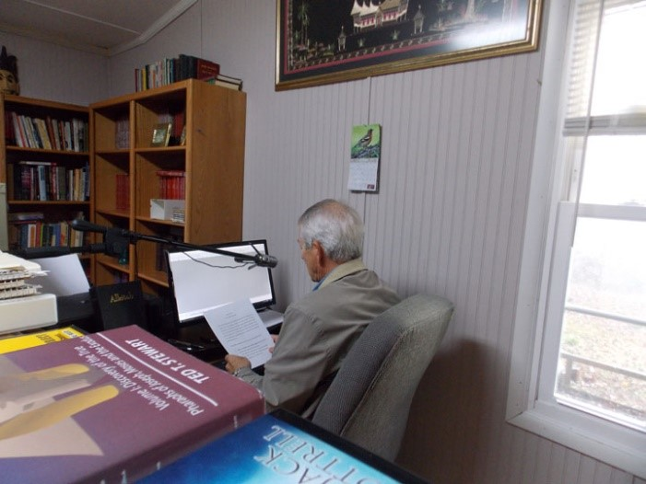

Colin Recording Indonesian radio programs

More flooding Jakarta Metro

Four children in Connor House, Bekasi

Trash from Daniel’s house after flood

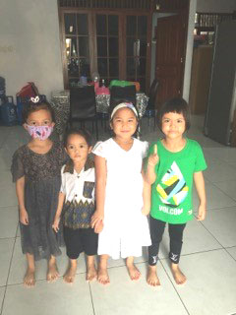

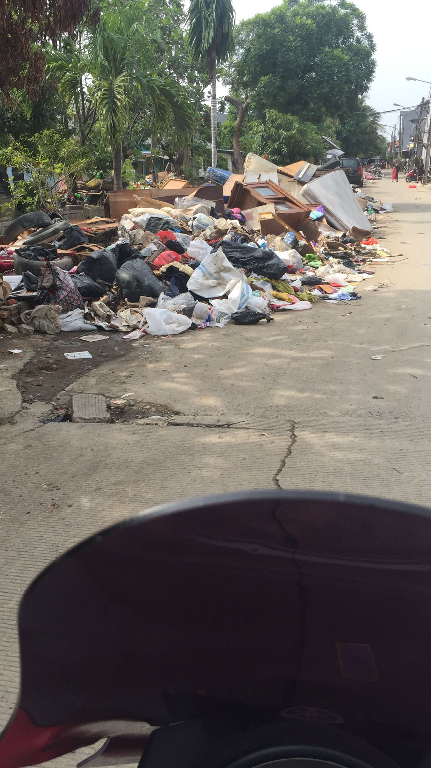

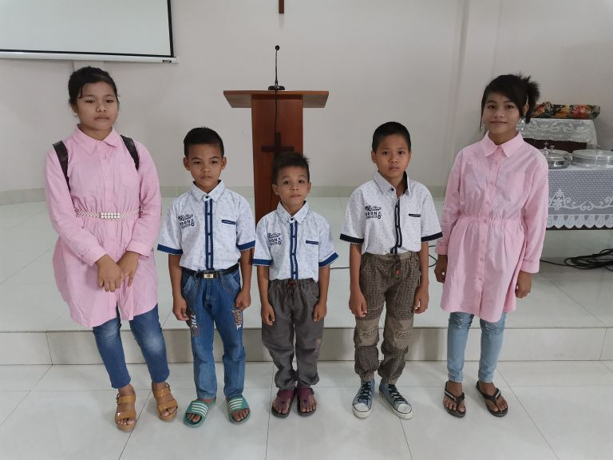

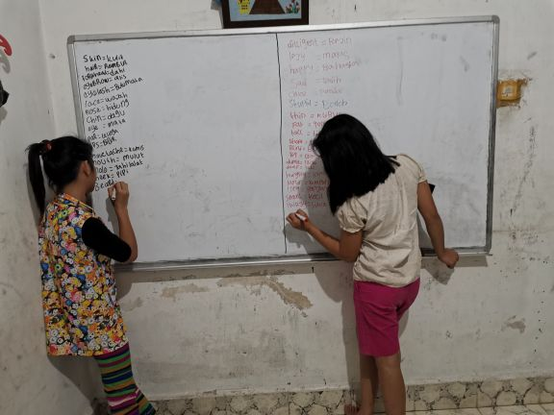

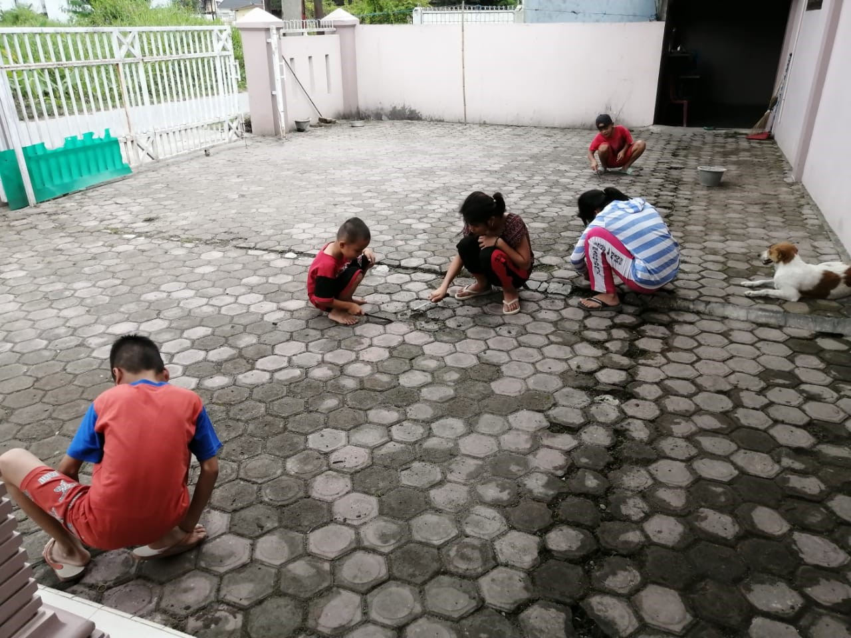

Medan orphans cleaning porch of church building

Baptism in Medan

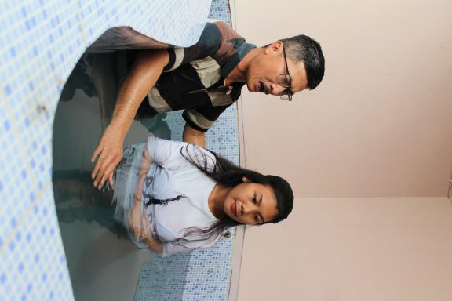

Recent baptism, Medan

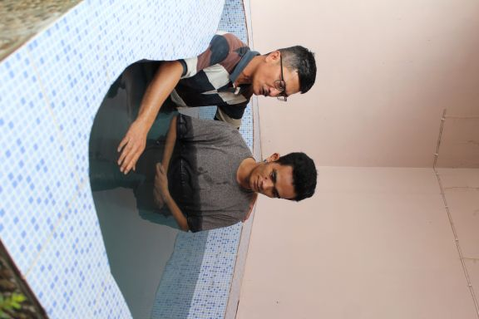

More homework

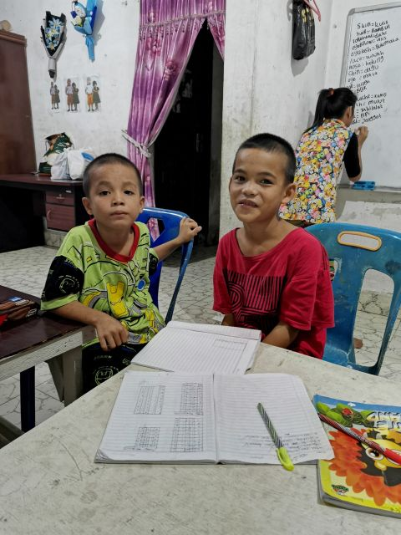

Home worship, one of Medan Selayang families

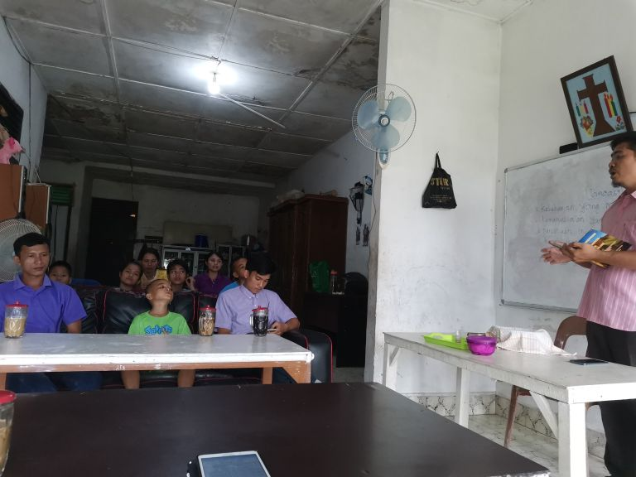

Bro Alip’s flooded house , Jakarta

Medan orphans doing homework

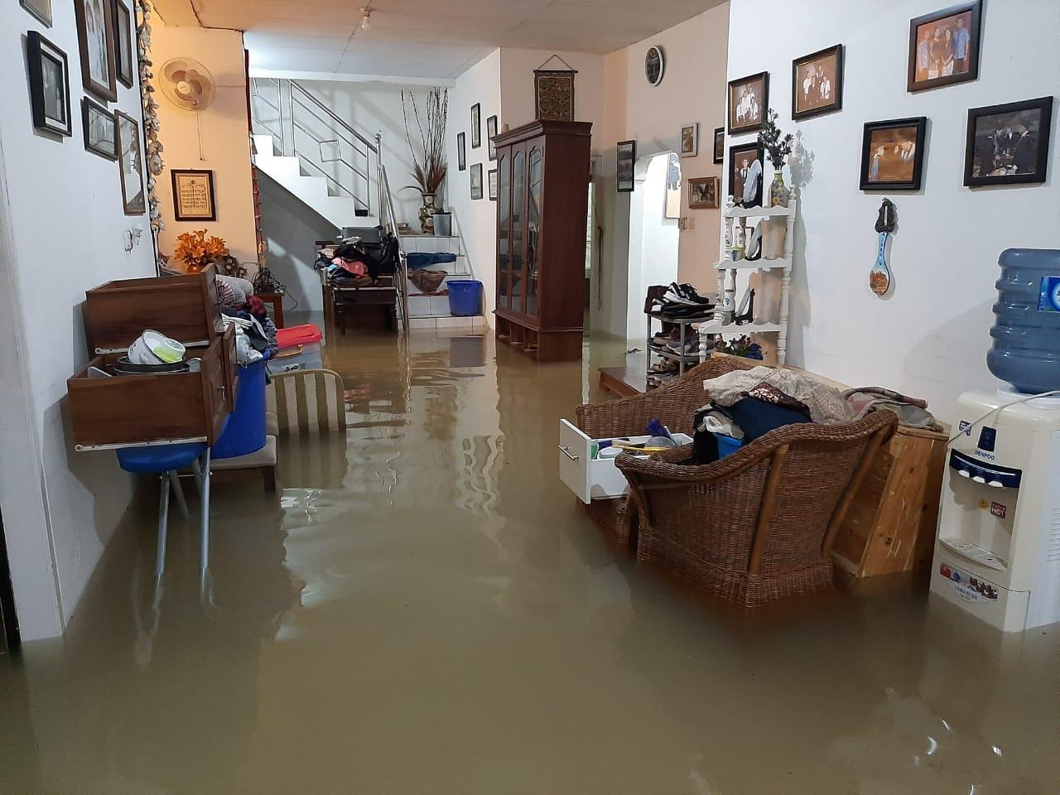

Five orphans at Selayang Medan

Husband and wife